**ShopNest Store Capstone Report**

1. **Top 10 categories by total price**

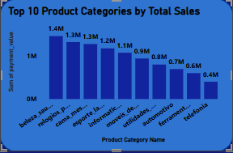

It is observed that the product category ‘Beleza Saude’ is the category that has the highest sales and the ‘Telefonia’ has the lowest sales.

1. **Delayed Order Analysis**

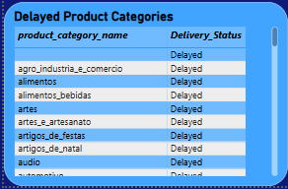

There are total 70 product categories which are delayed.

1. **Monthly Comparison of Delayed and On Time order**

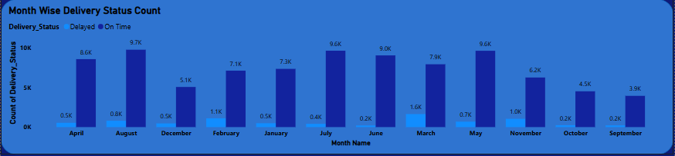

From this chart it is observed that in every month most of the orders are delivered ‘On Time’ and there are very less orders which are ‘Delayed’.

1. **Payment Method Analysis**

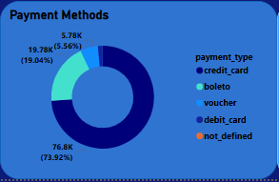

For payment methods it is observed that ‘Credit Card’ method is the most used payment method among all which the customers like the most and ‘Debit Card’ is used as the least.

1. **Product Rating Analysis**

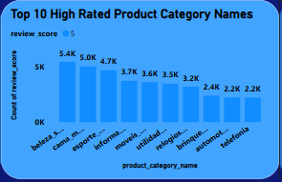 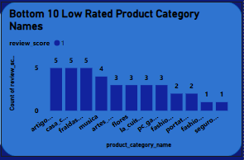

Here is the list of top 10 high rated products and bottom 10 lowest rated products by their categories.

1. **Seasonal Sales Pattern**

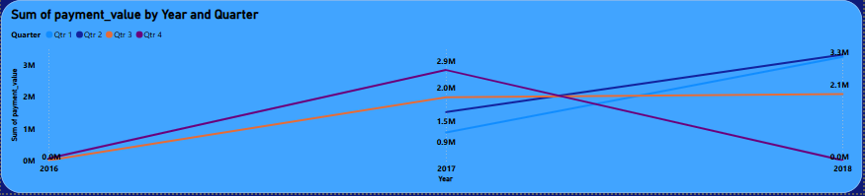

1. **Revenue Analysis**

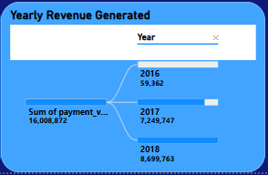

From this chart it is observed that in the year 2018 the revenue is generated the most and in year 2016 the revenue generated the least.

The pattern is seen that the progress is improving every year. We can see that the revenue generated in 2017 is also good and in 2018 also increased.